Performance Analysis of FM System under Gaussian White Noise using MATLAB

AIM :
• To simulate an FM system using MATLAB and analyze its performance under Gaussian white noise.
• To study the effect of noise on the FM signal and evaluate the output signal-to-noise ratio (SNR).

CODE:

clc;
clear;
close all;

Am = 1; % Message signal amplitude
fm = 100; % Message frequency (Hz)
fc = 1000; % Carrier frequency (Hz)
fs = 20000; % Sampling frequency
t = 0:1/fs:0.05; % Time vector
kf = 200; % Frequency sensitivity
SNR = 10; % Signal-to-noise ratio (dB)

% Message Signal
m = Am*cos(2*pi*fm*t);

% FM Modulation
int_m = cumsum(m)/fs;
s = cos(2*pi*fc*t + 2*pi*kf*int_m);

% Add Gaussian White Noise
r = awgn(s, SNR, 'measured');

% FM Demodulation
analytic_signal = hilbert(r);
inst_phase = unwrap(angle(analytic_signal));
inst_freq = [diff(inst_phase)*fs/(2*pi), 0];

% Recover Message Signal
demod = (inst_freq - fc)/kf;

% Remove DC component
demod = demod - mean(demod);

% Calculate Signal-to-Noise Ratio
m = m - mean(m);
demod = demod - mean(demod);

error_signal = m - demod;
output_SNR = 10*log10(mean(m.^2)/mean(error_signal.^2));

% Plot Results
figure;

subplot(4,1,1);
plot(t,m);
title('Original Message Signal');
xlabel('Time (s)');
ylabel('Amplitude');
grid on;

subplot(4,1,2);
plot(t,s);
title('FM Modulated Signal');
xlabel('Time (s)');
ylabel('Amplitude');
grid on;

subplot(4,1,3);
plot(t,r);
title('FM Signal with Gaussian White Noise');
xlabel('Time (s)');
ylabel('Amplitude');
grid on;

subplot(4,1,4);
plot(t,demod);
title('Demodulated Signal');
xlabel('Time (s)');
ylabel('Amplitude');
grid on;

fprintf('Input SNR = %.2f dB\n', SNR);
fprintf('Output SNR = %.2f dB\n', output_SNR);

OUTPUT:

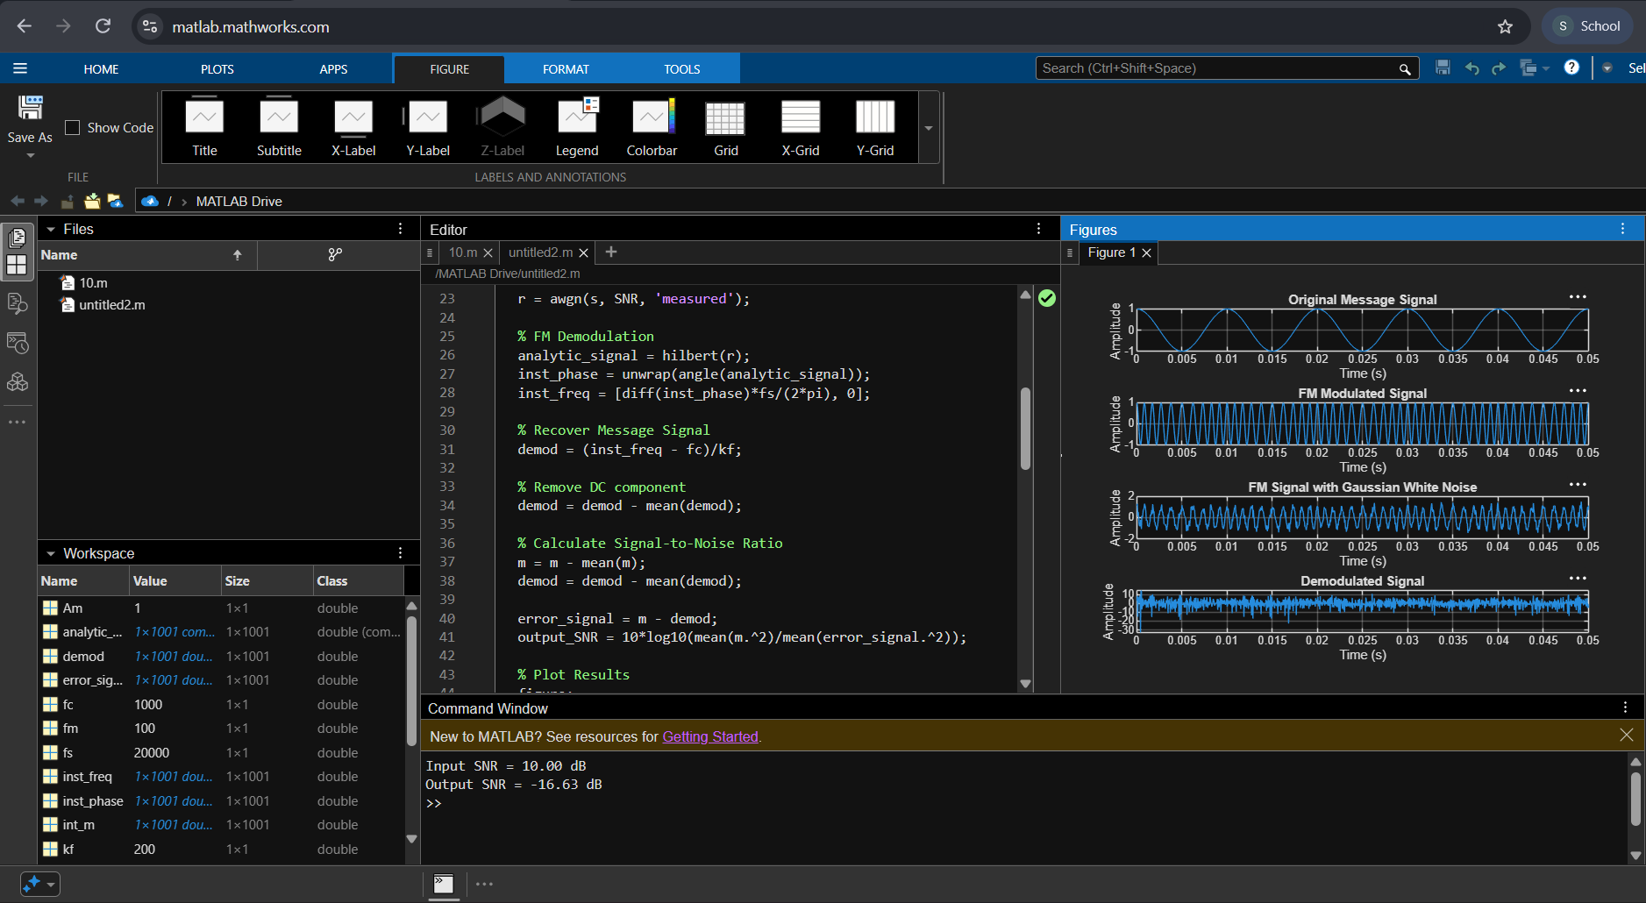

RESULT :
• The FM signal was successfully generated, and Gaussian white noise was added using MATLAB.
• The noisy signal was demodulated, and its performance was analyzed by comparing the input and output SNR.

